Name:  Class: | ____________________________________  ________________ |  | Date:_________
 | Year 11 Foundations Mathematics Test - 2021  $\frac{ }{32}$  Topic – Time
Total Time: | 45 minutes
Weighting: | 5%
Equipment: | None

Answer all questions in the space provided.

Question 1 [1, 1, 1, 1= 4 marks]
Complete the following questions.
a) Show 3:10 on the clock face.  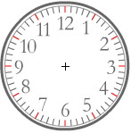  c) Write down the time the following clock shows.    The time is:________________ | b) Show a quarter past 4 on the clock face.    d) Write down the time the following clock shows.  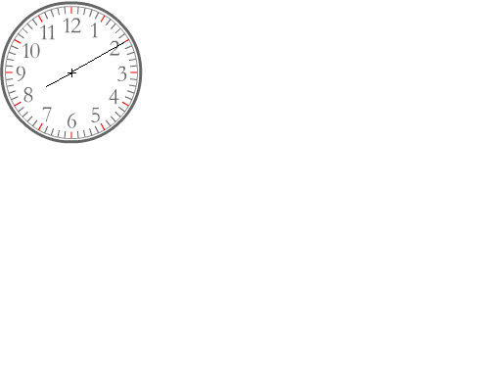  The time is:________________

Question 2 [2 marks]
Select one of the tools listed below, that are used to measure and track time, as the most appropriate to measure the elapsed time for the following events.

Tools: Calendar Clock Stopwatch

- Running 100m in a race
- Working for a day in a work placement
Question 3 [1, 1, 1, 1= 4 marks]
  - Express 245 minutes in hours and minutes.
  - Express 112 seconds in minutes and seconds.
  - What is the time 35 minutes before 9.15am?

  - Express 8 days 15 hours in hours.
Question 4 [half mark each = 4 marks]
Convert the following:
  - 240 seconds = minutes
  - 2.5 minutes = seconds
  - ½ hr = minutes
  - 90 min = hours
  - days = hours
  - 48 hour = days
  - 2 hour = seconds
  - 3 weeks = days

Question 5 [3 marks]
Place the following in order from shortest length of time to longest length of time. Write 1st next to the shortest, then 2nd and then 3rd for the longest event.

Steve completes the following activities in his workout at the gym:

- training circuit that he completes in 12 minutes
- stretches that he completes in 120 seconds
- jogging on a treadmill that he completes in half an hour

Question 6 [1, 1, 1, 2 = 5 marks]
Answer the following questions for the following bus timetable:
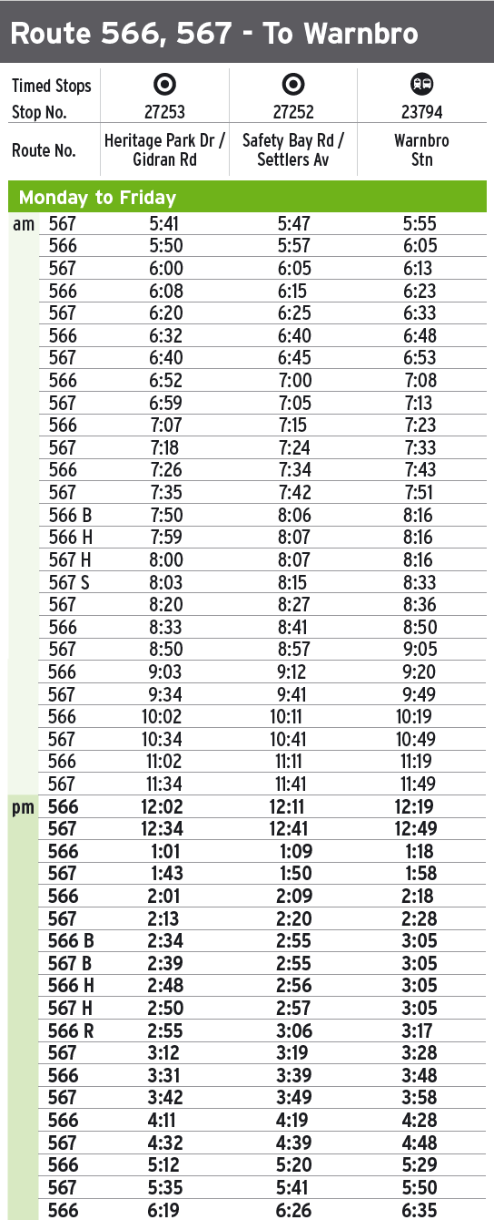
- To arrive at Warnbro Station for 8:50am what time would you need to catch the bus from Heritage Park Drive?

- What is the Route Number of the bus you would catch to Warnbro Station for 8:50am?

- What time does the 566 B arrive at Warnbro Station?

- How long does the 567 that leaves Heritage Park Drive at 3:12pm take to get to Warnbro Station?

- If it takes you 10 minutes to walk to the bus stop and you catch the 567 S in the morning from Safety Bay Road, what time would you need to leave to arrive at the bus stop on time?

Question 7 [1, 1, 1, 1 = 4 marks]
Calculate the time that elapses between the following times.

- 4pm and 11pm _________________________________________________
- 6:30am and 9:40am ______________________________________________
- 5:25pm and 9:33pm ______________________________________________
- 7:52am and 10:28pm _____________________________________________

Question 8 [1, 1, 1, 1 = 4 marks]
Use the calendar to answer the questions.
- How many days are in January?
- What day of the week is January 17?
- How many Mondays are in January?
- Jenny left for a holiday on Wednesday 2nd January and arrived home exactly 2 weeks later. On what date in January did she arrive home?

Question 9 [1, 1 = 2 marks]
Here is part of the morning train timetable from Perth to Midland.

Perth | 07:11 | 07:20 | 07:27 | 07:35 | 07:43 | 07:55
Maylands | – | 07:28 | 07:33 | 07:43 | 07:49 | 08:03
Ashfield | – | – | 07:38 | – | 07:54 | –
Success Hill | 07:25 | – | 07:41 | – | 07:57 | –
Midland | 07:32 | 07:41 | 07:48 | 07:56 | 08:05 | 08:16

Mr Power is in Perth and wants to be in Midland by 08:00.
- What is the time of the latest train he can take from Perth?

- If it takes him 15 minutes to walk to Perth station, what time should he leave to catch the train on time?

